2018 WA State Fatherhood Summit Notes

Day 1: Making Connections with Fathers in Mind
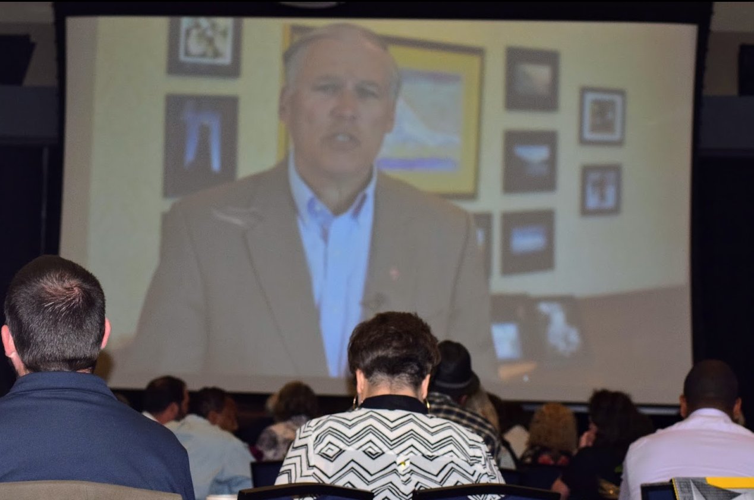
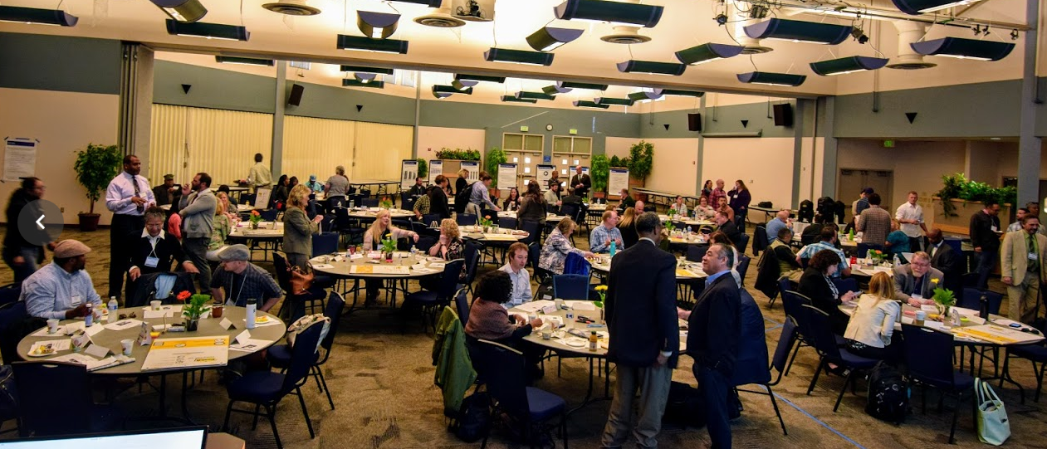
Welcome! 140 participants checked in to attend the two-day Washington State Fatherhood Summit. Fifty percent of the attendees were fathers and over half of the fathers in the room came to the summit specifically to share their lived experience as dad. Participants traveled from all over the state and represented community service providers, education, state agencies, advocacy groups, medical providers, many more. The list of attendees is in the attachments section at the end of this document.
The Summit kicked off with a welcome video from Governor Jay Inslee, which was introduced by Jim Baumgart from the Office of the Governor.
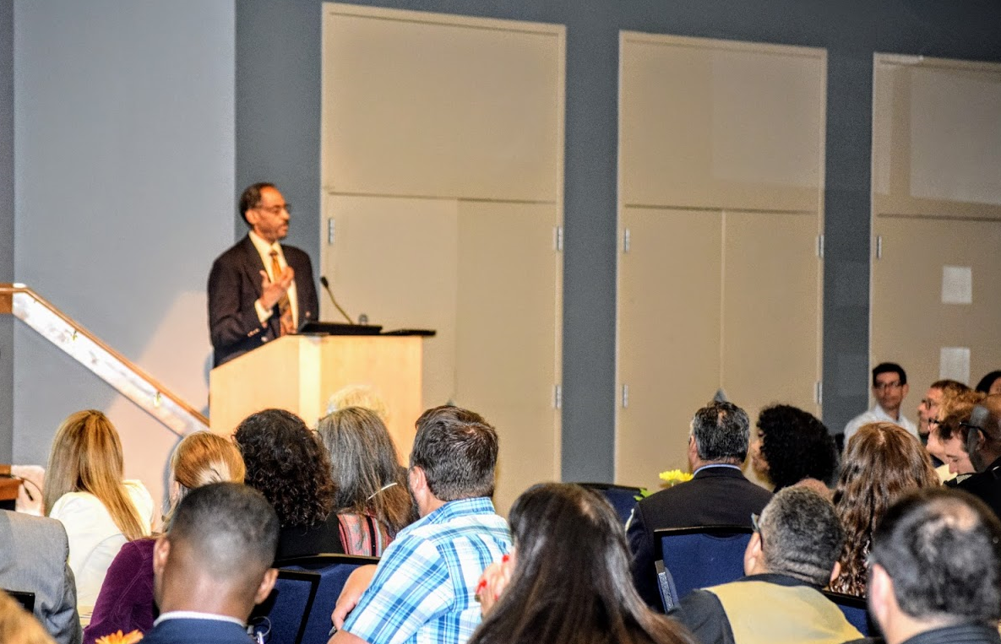
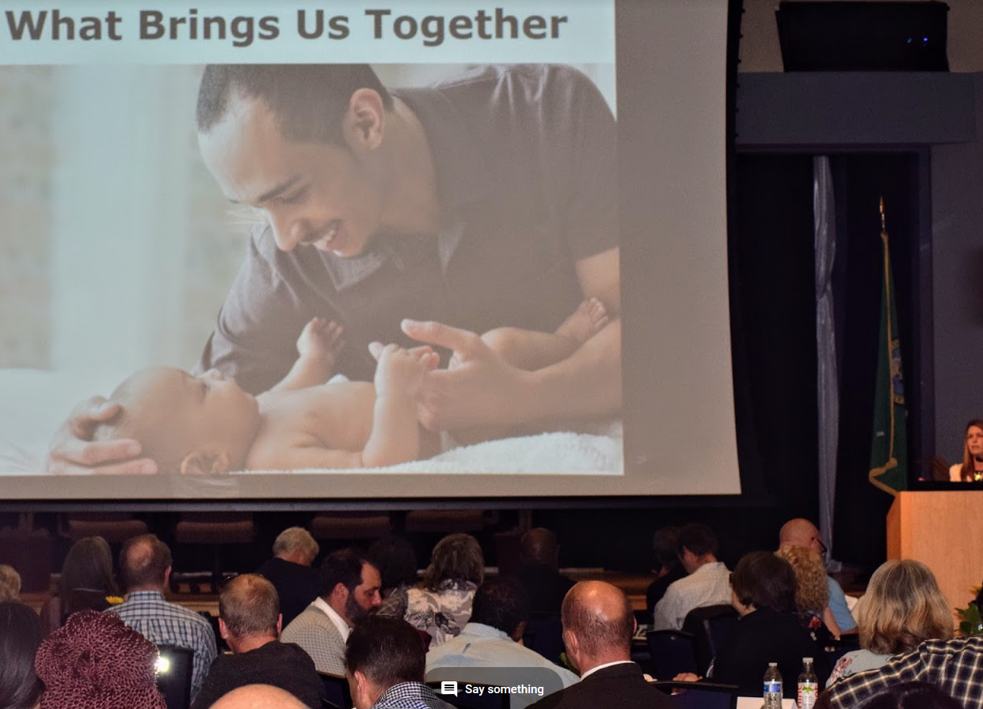
Opening Remarks: Dr. Holly Schindler of the University of Washington school of Education and Fellow at the Harvard University’s Center on the Developing Child presented opening remarks that grounded the group in what brings us together and a high-level overview of the 3 Principles to Improve Outcomes for Children and Families from the Harvard Center on the Developing Child. She then introduced Dr. Ronald Mincy of Columbia University. More information about the topics Dr. Schindler covered during these opening remarks and on day two of the Summit can be found on The Center’s website: https://developingchild.harvard.edu/
Keynote address: Failing Our Fathers by Ronald Mincy, Ph.D of Columbia University and author of the book, Failing Our Fathers. Dr. Mincy introduced a historical view of the public’s understanding of fatherhood and discussed national trends around family structure, economics of fatherhood, the critical role that fathers play in child development, and assumptions and stigma around fatherhood engagement. A copy of his slide deck is in the attachments section at the end of this document.
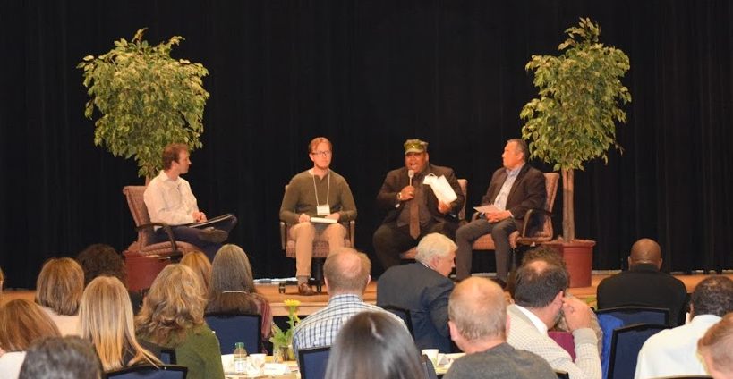
Fatherhood Panel: Fathers from across the state joined the conference to share their stories and join the summit. Three fathers shared their experiences as a father in a panel discussion moderated by Jessup Coffin, the Conscious Fathering Program Coordinator, and a Conscious Fathering Instructor. Jessup is also a Childbirth Educator, Certified Lactation Educator, Babysafe Instructor, CPR/First Aid Instructor and Birth Doula. He currently teaches Conscious Fathering at any of the 17 Pierce, King, and Snohomish county site locations, as well as performing community outreach and Conscious Fathering presentations.
Panelists:
James Moore
I am the proud father of a 3 year old monster truck lover named Charles. I live in Tri-Cities, Washington and being a father has been one of the most exciting journeys I have been on. I'm thankful to be here at this summit, I've always wanted an opportunity to share my perspective as a father so that others can learn from my experiences. I am looking forward to meeting as many of you as I can!

Anthony L. Gayle "Tony"
I am a humble Servant, widower, disabled combat Veteran, and, most importantly, a Father to an amazing developmentally delayed 4 year old toddler named Hezekiah. His blessed mother, my wife, passed away during childbirth and "Hezzy," was born at 29 weeks, 2.4 lbs. He didn't walk until 2yrs, I refuse to allow my son to fail. Early retired with the help of Washington state services & my professional village who went above and beyond to give therapy, they also choose to care.

Carlos Mejia Rodriguez
I migrated to US from Honduras in mid-2002. My wife and three children aged 1, 3, and 11 years old migrated 6 months later. As physician in my country, I experienced the difficulties of fatherhood for migrant fathers after separation and the challenges to adapt to many cultural differences. Now I live in Olympia and am excited to share my fatherhood experience with others.

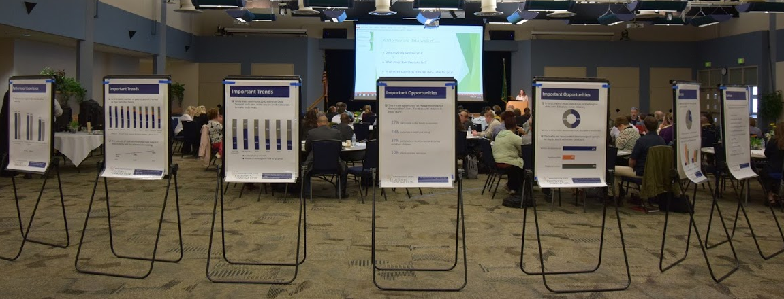
Examining Data to Tell the Story: Dr. Lori Pfingst, Chief of Programs and Policy for the Community Services Division, Economic Services Administration, Department of Social and Health Services, led the group through the process of examining some national, state, program, and pre-summit survey data. Posters from the data walk and questions are included in the attachments section located at the end of this document.

Table Discussions: Participants were instructed to return to their table groups and reflect on what we heard from speakers, panel of fathers, and the data walk and relect on the following questions:
- Based upon what we have heard so far in natl’ and state data what surprises, excites, or concerns you? What did you hear from the Father’s Panel that we want to shine the light on and pay attention to as we build the plan?
- What things have you learned or might do differently when you go back to your day job?
Using sticky notes, the group was encouraged to brainstorm ideas of policy, system, and program strategies that, individually, the group wanted to see in
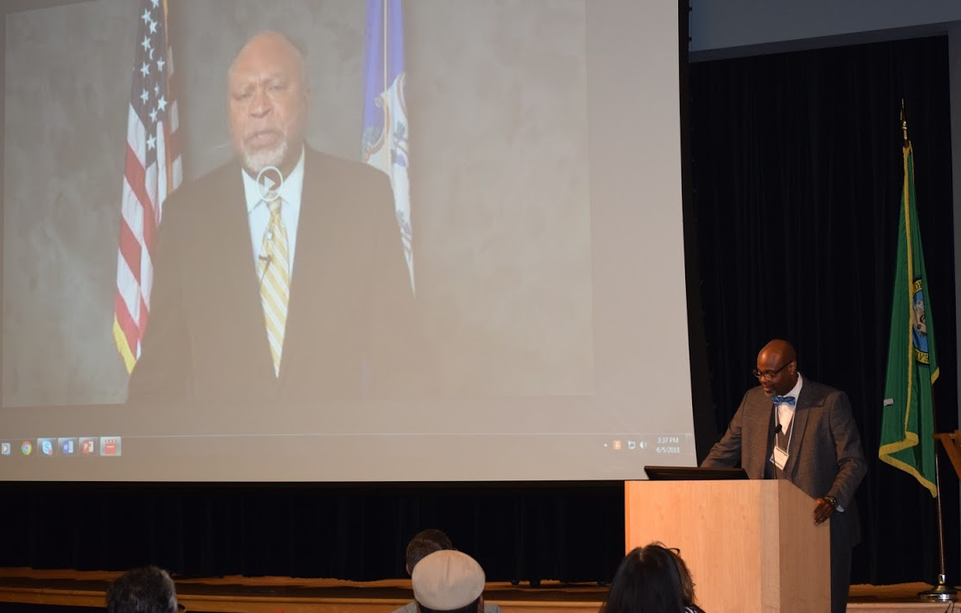
Plenary Address: Fatherhood Initiative of Connecticut: Promoting Positive Involvement of Fathers Since 1999: Connecticut state Department of Social Services Roderick Bremby joined the Summit by video. Lead staff from the Connecticut Fatherhood Initiative, Anthony (Tony) Judkins and Diana DiTunno shared their 19 year journey of collaborations and work that is focused on changing systems that can improve fathers’ ability to be fully and positively involved in the lives of their children. A dialogue followed the presentation with the whole audience that inspired hope for a Washington Statewide Plan for Fatherhood.

Day Two: Generating a Statewide Plan for Fatherhood
Welcome! Summit participants gathered together for the second day and were welcomed by a video from the Department of Social and Health Services’ Secretary Cheryl Strange.
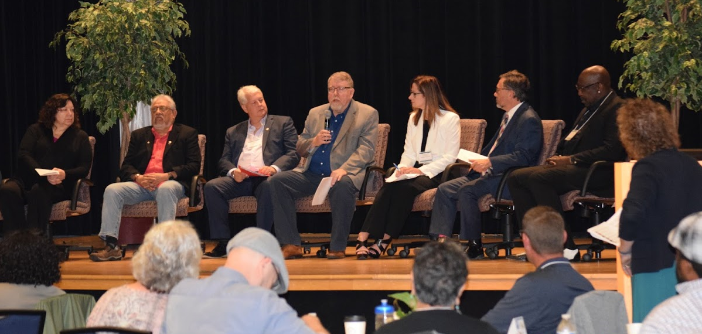
Leadership Panel: WA Frontiers of Innovation Statewide Systems and Policy Director, Anne Stone, moderated a panel of leaders from public and private agency in a discussion around the opportunities we have heard to move forward our planning efforts. Questions to begin the discussion were collected from the pre-summit survey that went out to those who registered to attend the Summit. The discussion was followed by a curated Question and Answer session that generated a lot of energy around exciting opportunities to improve systems, policies and programs for fathers.
Panelists:
David Stillman: Dept. of Social and Health Services Assistant Secretary of Economic Services Administration.
Toni Sebastian: Director of Program and Policy at Children’s Administration.
Danielle Armbruster: Assistant Secretary of the Re-entry Division at the Department of Corrections
Wally McClure: Director of the Division of Child Support at the Economic Services Administration.
Greg Williamson: Assistant Director of Partnerships and Collaboration at the Department of Early Learning
Marvin Charles: Founder and Director of Devine Alternatives for Dads Services in King County.
Joseph Garcia: Founder and key Leader of King County Community Partnership for Transition Solutions and an Instructor at South Seattle Community College
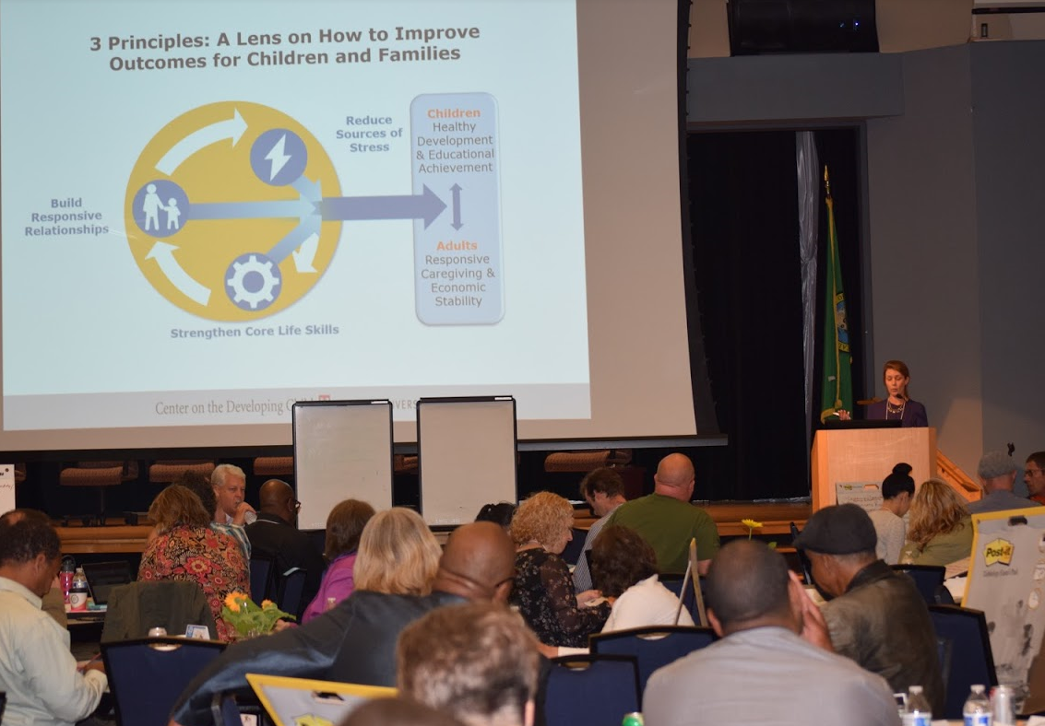
Brain Science Lens in Action: Dr. Holly Schindler re-introduced the 3 Principles to Improve Outcomes for Children and Families as one way to use what we know about how children and adults navigate through their lives as the group moved into the next steps toward thinking about and choosing some strategies that we want to see in the statewide plan.

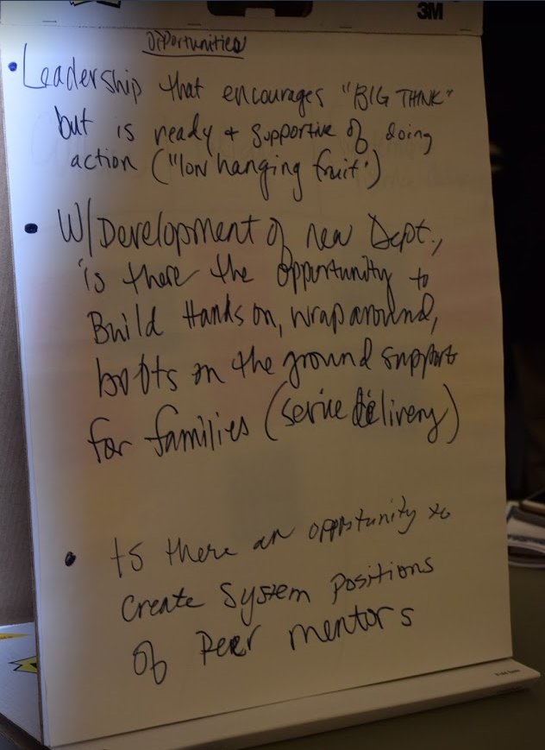
Table Discussions: Using that lens and reflecting back on the sticky-note brainstorming exercise from day one, attendees went back into their table groups to discuss the following questions and activity:
What are two or three key takeaways from what you heard from the agency leadership panel conversation?
Were there any successes or opportunities that we should consider?
Using the easel paper, discuss and work toward prioritizing the ideas generated by your table.

Setting Priorities: The participants were asked to reflect on all of the learnings from the past two days and ideas generated from the activities and create one card for the two strategies that they wanted to vote upon at the end of the two-day summit. The responses are summarized below in these three groupings:
- Value statements that are cross cutting
- Strategies that received multiple
- Single strategies that are very focused
Values statements
- Advocate for fragile families and equal rights for fathers
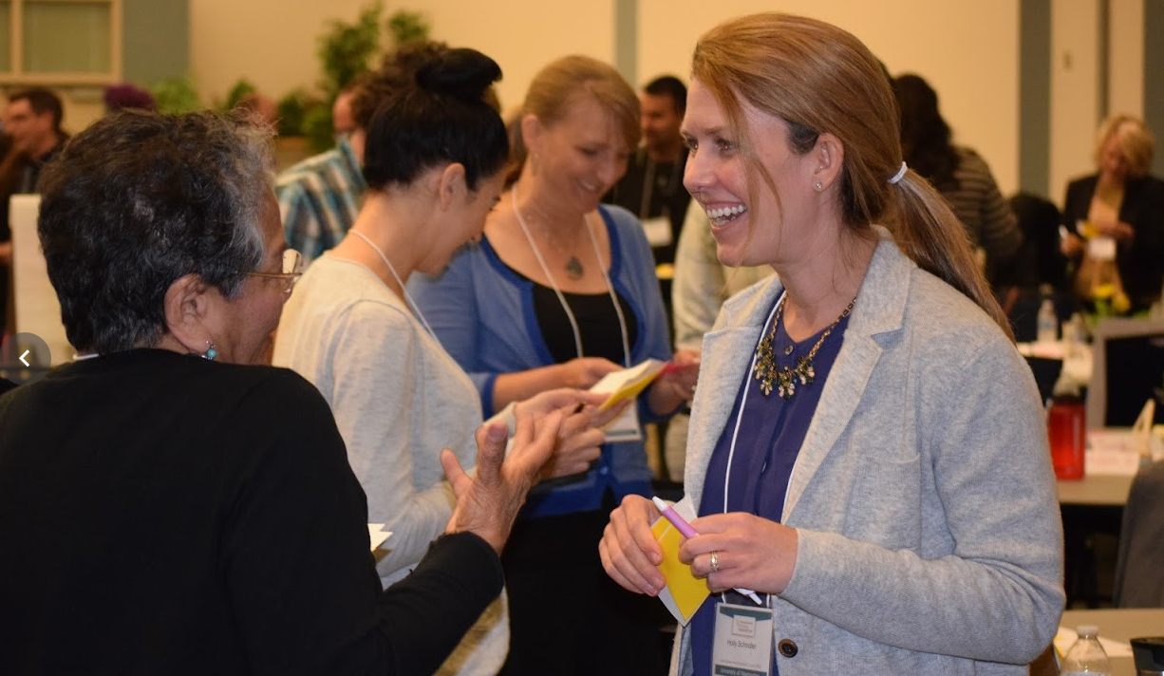
- Recognize the diversity of families and create programs that support that diversity
- Retool line staff across agencies to be more empathetic and to ask fathers what we can do for them “a human touch and understanding are so important, clients are people with needs but they don’t always feel like they are valued”
- Support child focused, family focused policies, practices, and measures
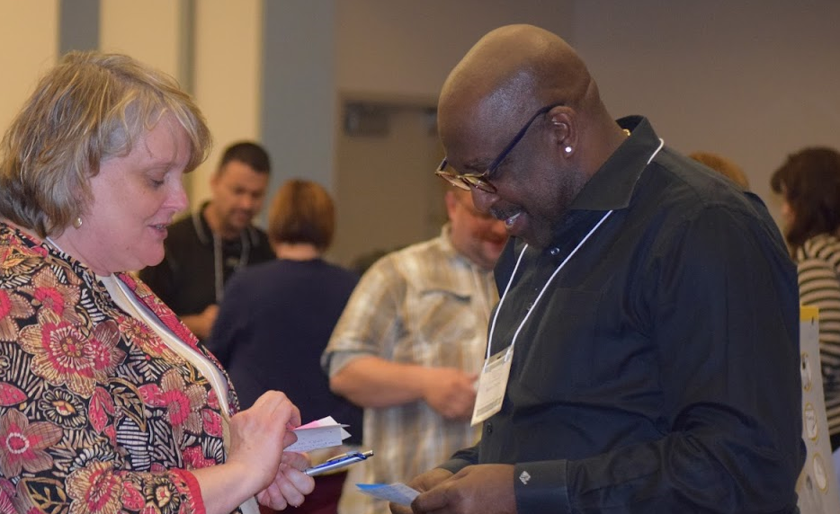
- Use common/neutral language that reflects families versus Mom vs Dad
- Support fathers as a target audience across the continuum of care
- Push funding to community based services that are often more culturally sensitive
- Create a statewide definition of family that is cross cutting
- Enhance intake processes across agencies that are child centric with open questions about families’ needs, challenges and assets.
- Create and strive for equitable service provision to mothers and fathers caring for children

Strategies summarized with the number of cards and the voting range out of a possible 25 points
Continue and strengthen inter agency collaboration to increase communication, common planning and synergy that might include a Memorandum of Understanding (MOU) overtime | 11 cards that ranged from 11 to 22
Establish and support Fatherhood Council that advises all agencies with members that represent diversity (geography, age, system experience, race and ethnicity) across the state. | 9 cards that ranged from 18 to 25
Support and grow local community convenings of fathers in ongoing groups, focus groups, peer to peer mentoring opportunities. | 9 cards ranging from 17 to 22
Training for state agency staff on ACE’s, trauma, resilience, implicit bias, impact of fathering on child development (i.e. serve and return), neutral language promotes family versus mother or father. Recognize that the language that we use around parenting and families matters. | 9 cards ranging from 17 to 25
Education and training for youth and young men about ACE’s trauma, toxic masculinity, and parent preparation. | 9 cards ranging from 13 to 25
Expansion of parent education for fathers that includes counseling, strong outreach, co-parenting and coaching to improve confidence and bonding | 10 cards ranging from 10 to 22
Division of Child Support – at paternity offer more parenting services, increase flexibility around support orders that incentivize parenting programs, co-parenting plans, link to jobs when someone can’t pay, adopt residential credit as part of formula, forgive arrears tied to quality child interactions. | 14 cards ranging from 15 to 21
Department of Corrections – increase access to visitation (in person, phone, video etc), parenting programs, support fathers in dependency issues, explore continuum of care for teen parents, child development, connections to community resources strengthened at re-entry, parenting plans post incarceration, strengthen families project | 10 cards ranging from 11 to 23
Community Services Division (TANF and SNAP) – make offices more like resource center and more family friendly, make all service available to Non Resident fathers when on assistance, qualify NRF on food assistance, provide life skills and employment training to both parents when one on TANF, father friendly Bulletin Boards with resources specifically for fathers, enhance data system to prominently ID NCP, WorkFirst IRPs from custodial parent to the child, plan to support the child needs to include NCP, create consistent poverty level cutoffs for eligibility for programs. | 10 cards ranging from 10 to 21
DCYF – Department of Early Learning – Increase early education supports that emphasis health family relationships, fathering and co-parenting. Invest heavily at the birth of a child at entry to incarceration and at separation from a child. | 4 cards ranging from 16- 23
DCYF – Children’s Administration – focus on families and reduce bias toward mother, 50/50 parenting, increase parenting plans that include both and simply the process to set up and modify. Create incentives for parenting plans increase father visitation | 3 cards ranging from 10 to 19
Recruit, train and support the hiring of more men with lived experience around fatherhood and challenging systems. Increase representation of the community served. Always groom men into professional roles | 7 cards ranging from 7 to 22
Centralized State-wide Resource directory, include private sector, more proactively connect fathers to resources, meaningful, interactive, up to date, include communication plan on how people connect to the resources, agencies promote resource directory, people need to know what is available where they need it. | 10 cards ranging from 14 to 25
Create and sustain more Family Resource Centers (One stop Shops) that include resources for fathers. Simply the process for families, bundle services to help families succeed early and normalize all families. Co-locate as many services as possible in one place and process | 4 cards ranging from 14 to 22
Mandatory Family Leave for both parents regardless of residential status | 3 cards ranging from 14 to 22
Create and nurture Agency Navigator roles that work across disciplines, mentors for fathers to increase access to services | 2 cards 10 and 16
Policy changes – parental equity, family court reform, language of current policy to make more fatherhood inclusive, policy review that biases mother over father. Include fatherhood in discussions of equity, diversity, and inclusion. | 7 cards ranging from 17 to 22
Single focused strategies:
- Increase genetic testing in hospitals to make more consistent - vote 9
- Conduct a judicial training on bias against fathers
- Provide fatherhood resources through employers, awareness campaign, skills groups- vote 17
- Family planning for fathers in any state agency program- vote 17
- Implement rapid cycle learning projects that might go to scale – vote 16
One card listed who is missing at this summit:
- Prosecutors office
- Judicial officers
- Federal agency partners
- Legislators
Moving to Commitment and Action: Once the cards had been scored, participants were asked to raise up cards that received the highest scores out of 25. The group discussed this preliminary list of priorities until we arrived at 10 Strategies to vote upon for further exploration and action over the next year. The 10 strategies were voted on using a tool through mentimeter.com and the results were as follows:
- Fatherhood Advisory Council
- State staff training on fatherhood engagement, training on ACES
- Invest in early education and intervention
- Accessible Resources -Finding what you need, when you need it
- Peer Mentorship/Collaboration of fathers
- Increase access to children for incarcerated dads, including parenting classes and reentry skills
- Institutionalize life/parenting skills
- Policy changes for equitable custody
- Common Language about what we are doing
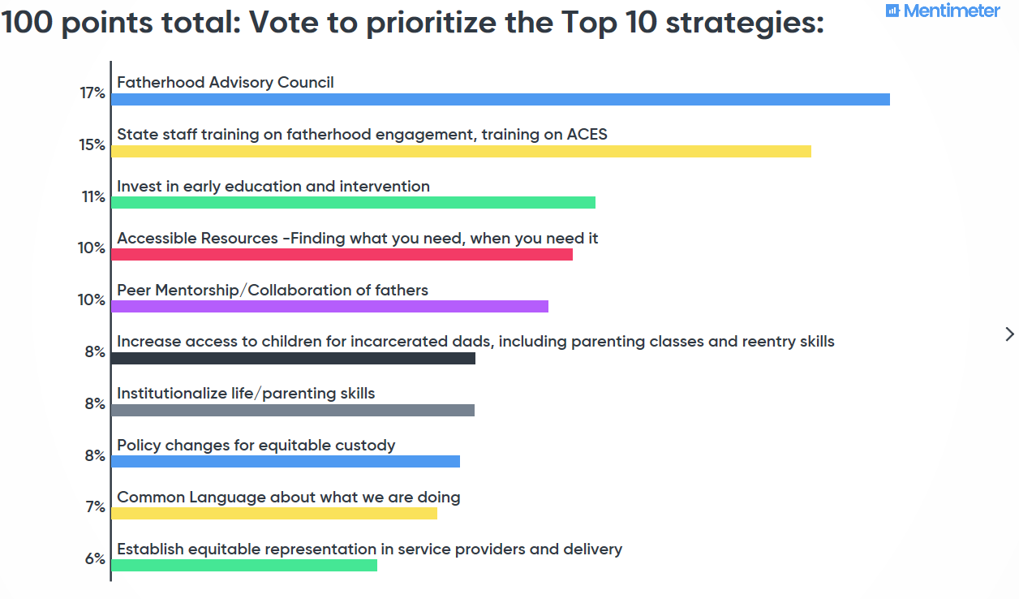
- Establish equitable representation in service providers and delivery
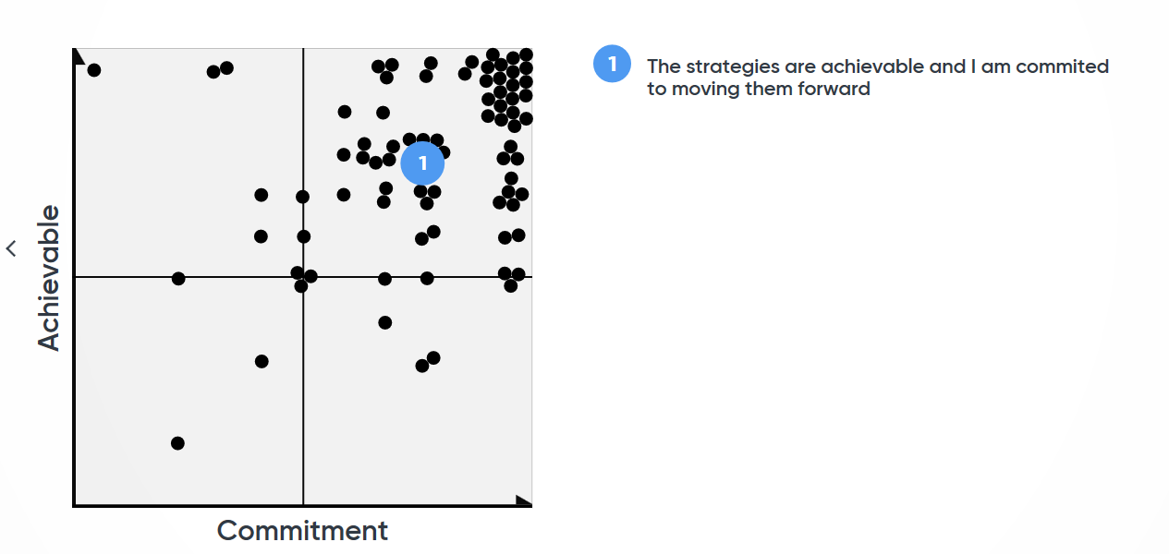
Finally, the group thought about the strategies that they just voted on and, again using the mentimeter.com tool, ranked the achievability of and their own level of commitment to pursuing the strategies over the next year. Overwhelmingly, there was a high level of commitment in the room and most participants believed that at least some of the strategies identified and voted upon are achievable.

Attachments:
ATTACHMENT A: Attendees & Contact Information
ATTACHMENT B: Dr. Ronald Mincy Presentation Slide Deck
ATTACHMENT C: Data Walk Posters & Questions

