Special Thanks to Our Partners and Contributors:  United Way of Skagit County  WA State Frontiers of Innovation  South Seattle Colleges  Department of Social & Health Services  Economic Services Administration  Division of Child Support;  Community Services Division;  Tribal Liaison  Children’s Administration  Rehabilitation Administration  Department of Early Learning  Department of Corrections  Department of Health  Administration for Children and Families  WA State Fathers Network  Office of the Superintendent of Public Instruction  WA Office of Public Defense  South Seattle Colleges  King County Community Partners for Transition Solutions  Children’s Home Society of WA  Divine Alternatives for Dads Services (DADs)  Partnership for Fathers and Families –Snohomish, King, Pierce  University of Washington  Want to join the Fatherhood Steering Committee?  Contact Us!  Phone: 360 725-4547  Email: info@wafoi.org  Web: www.wafoi.org  8 |  |  |  | 2018 Washington Fatherhood Summit  June 5 & 6, 2018  - South Seattle College | Brockey Center
2-Day Summit Agenda  Day One: Making Connections with Fathers in Mind  8:00-8:45 Registration & Breakfast  8:45-9:00 Welcome! Governor Jay Inslee  9:00-9:30 Opening Remarks Dr. Holly Schindler  9:30-10:30 Keynote address: “Failing Our Fathers” Dr. Ronald Mincy  10:30-10:45 Break  10:45-12:00 Voices of Fathers Sharing Their Powerful Stories  12:00-12:45 Lunch & Networking  12:45-2:30 Examining Data to Tell the Story Dr. Lori Pfingst  2:30-2:45 Break  2:45-4:00 Table Discussion & Activity  4:00-4:45 Plenary Address: Fatherhood Initiative of Connecticut: Promoting Positive Involvement of Fathers Since 1999 Commissioner Roderick Bremby  4:45-5:00 Closing Remarks Dr. Holly Schindler  Day Two: Generating A Statewide Plan for Fatherhood  8:30-9:00 Welcome & Breakfast  9:00-10:30 Leadership Panel Moderated by Anne Stone, WA FOI Director  10:30-10:45 Break  10:45-12:00 Table Discussion & Activity  12:00-1:00 Lunch & Networking  1:00-1:15 Brain Science Lens in Action  1:15-2:30 Setting Priorities for a Statewide Plan  2:30-3:00 Moving to Commitment and Action  3:00-3:30 Closing Remarks & Call to Action  2 |  |  |  | Leadership Panel  David Stillman is the Dept. of Social and Health Services Assistant Secretary of Economic Services Administration.  Toni Sebastian is the Director of Program and Policy at Children’s Administration.  Danielle Armbruster is the Assistant Secretary of the Re-entry Division at the Department of Corrections  Wally McClure is the Director of the Division of Child Support at the Economic Services Administration.  Greg Williamson is the Assistant Director of Partnerships and Collaboration at the Department of Early Learning  Marvin Charles is the founder and Director of Devine Alternatives for Dads Services in King County.  Joseph Garcia Joseph Garcia is the founder and key Leader of King County Community Partnership for Transition Solutions and an Instructor at South Seattle Community College  7  7
Fathers Panel  Moderator Jessup Coffin  Jessup is the Conscious Fathering Program Coordinator, and a Conscious Fathering Instructor.  Jessup is also a Childbirth Educator, Certified Lactation Educator, Babysafe Instructor, CPR/First Aid Instructor and Birth Doula. He currently teaches Conscious Fathering at any of the 17 Pierce, King, and Snohomish county site locations, as well as performing community outreach and Conscious Fathering presentations.  Jessup is passionate about childbirth education, and facilitating the whole family in being involved in their child’s life from birth on. He brings an emphasis on how to support breastfeeding/chestfeeding, family mental health, and infant safety. He firmly believes that when a child receives great support from both parents, they have the greatest chance at improving the world around them.  Panelist Carlos Mejia Rodriguez  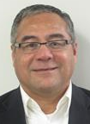  I migrated to US from Honduras in mid-2002. My wife and three children aged 1, 3, and 11 years old migrated 6 months later. As physician in my country, I experienced the difficulties of fatherhood for migrant fathers after separation and the challenges to adapt to many cultural differences. Now I live in Olympia and am excited to share my fatherhood experience with others.  Panelist James Moore  I am the proud father of a 3 year old monster truck lover named Charles. I live in Tri-Cities, Washington and being a father has been one of the most exciting journeys I have been on. I'm thankful to be here at this summit, I've always wanted an opportunity to share my perspective as a father so that others can learn from my experiences. I am looking forward to meeting as many of you as I can!  Panelist Wesley Thompson  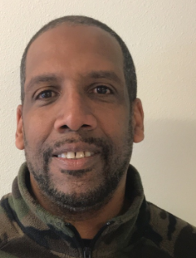  I am here to talk about the importance of programs for fathers like the YWCA’s Passage Point program and Family Treatment Court (FTC). As a youth, I lived in a poor & impoverished neighborhood which led to a life of crime & drugs, which is how I found FTC. Thanks to programs that I was dedicated to, such as family therapy, life skills, and learning about ACEs, I found heaven and understand the power of community!  6 |  |  | 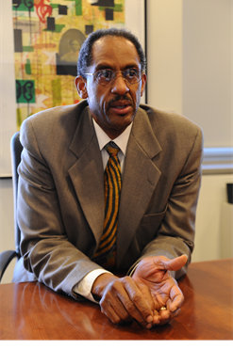  Keynote: Ronald Mincy, Ph.D.  Dr. Ronald B. Mincy is the Maurice V. Russell Professor of Social Policy and Social Work Practice at the Columbia University School of Social Work, and a co-principal investigator of the Fragile Families and Child Wellbeing Study. He came to the University from the Ford Foundation, where he served as a senior program officer and developed the Strengthening Fragile Families Initiative (SFFI).  Under his leadership, Ford Foundation grantees developed collaborative relationships with national and community foundations and local human service programs throughout the US. As result of SFFI, Dr. Mincy is widely regarded as a critical catalyst for the changes currently underway in the treatment of low-income fathers by U.S. welfare, child support, and family support systems. Dr. Mincy has published widely on the effects of income security policy on child and family poverty, family formation, child wellbeing, responsible fatherhood, the urban underclass, and urban poverty.  His most recent book, Failing Our Fathers, published by Oxford University Press, builds on his earlier work, examining the growth and diversification of vulnerable nonresident fathers, their attempts to provide financial and other support to their children, and the policy reforms needed to facilitate greater financial support and father engagement. As a Russell Sage Visiting Scholar in 2015/2016, Dr. Mincy continued his research, working in partnership with Dr. Natasha Cabrera, and focusing on the effects of resident and nonresident father earnings and financial support on child cognitive, academic, and behavioral outcomes.  Dr. Mincy’s undergraduate and graduate training in economics were at Harvard University and M.I.T. He and his wife of 41 years live in Harlem, New York. They have two sons, who, along with Dr. Mincy's two brothers, have inspired his interest in males throughout the life course and family well-being.  3
Plenary: Commissioner Roderick Bremby  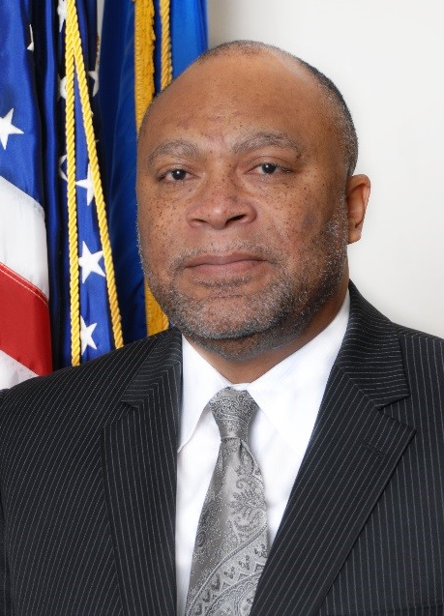  Commissioner Roderick L. Bremby joined Connecticut state government in April 2011 after an extensive career in Kansas and Texas, and academic service at the University of Kansas. He is currently serving in his second term as Commissioner of the Connecticut Department of Social Services (DSS). During his first six years at DSS, Commissioner Bremby has directed initiatives in areas of fatherhood, health care program reform and service innovation, modernization of technology and business processes and implementation of significant budgetary and legislative program changes.  The Commissioner has worked with the Governor’s Office, Office of Policy and Management and the Department of Administrative Services’ Bureau of Enterprise Systems and Technology to modernize the agency’s technology and service infrastructure during a time of increased program enrollment. DSS is the lead agency for the Connecticut Fatherhood Initiative (CFI), broad-based, multi-agency, statewide effort focused on changing the systems that can improve fathers’ ability to be fully and positively involved in the lives of their children.  Commissioner Bremby serves as Co-Chair of the Advisory Council and its Executive Team, a group of state and local leaders who guide the partners current work with the implementation of the CFI Strategic Plan. He is a member of several executive panels in state government, including the Governor’s Health Care Cabinet, Interagency Council for Ending the Achievement Gap, among many others.  Commissioner Bremby has contributed volunteer services to many civic endeavors and is the recipient of several awards and recognition including the American Public Human Services Association’s 2017 Outstanding State Member Award for leadership. Commissioner holds a Bachelor of Arts degree in communication studies and psychology, and a master of public administration degree, both from the University of Kansas.  4 |  | Master of Ceremonies: Holly Schindler, Ph.D.  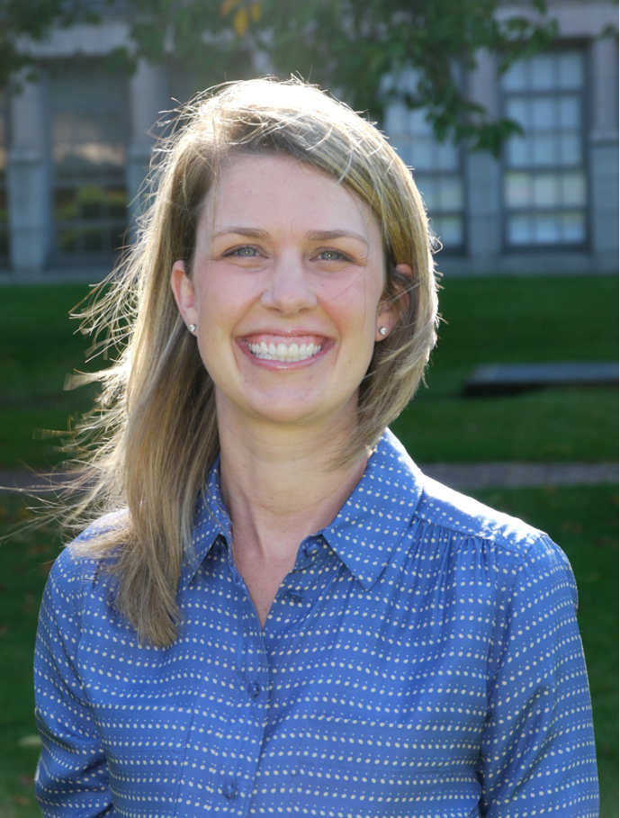  Dr. Holly Schindler is an Assistant Professor of Early Childhood and Family Studies at the University of Washington College of Education and a Fellow at Harvard University’s Center on the Developing Child.  Her work focuses on empirically identifying the features of early childhood programs that maximize benefits to children’s development and testing new strategies to boost the impacts of those programs.  She is currently implementing and evaluating a father-focused video coaching program in partnership with the University of Oregon and Children’s Home Society of Washington.  She also co-leads the Washington State Innovation Cluster, a cross-network collaboration of researchers, community-based practitioners, and state policymakers in the Frontiers of Innovation network working together to design, test, and scale a collection of early childhood intervention strategies meeting particular needs in Washington State.  Her research has been featured in top journals focused on child development, family relationships, program implementation, and public policy, and she was recently named as a Foundation for Child Development Young Scholar.  5

