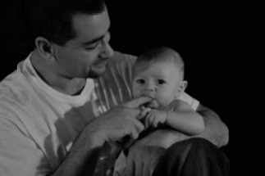
Connecting Fathers Workgroup
July 2nd, 10am-11am
724 Quince St Se Olympia WA AND WebEx - call in information in the appointment and email
Meeting Goals:
- Welcome and Introductions
- The goals of this group
- LI² Activities

Participants: Anne Stone, DSHS/ESA; Jeremiah Donier; Kyle Paskewitz; Amanda Krotke-Crandall; Tina Burnquist Alternative Solutions; Ellen Nolan DSHS/ESA

Topic | Notes
Welcome and Introductions  - Who is here?  - Review Agenda | All introduced themselves and a round robin check in was done around the expectations for the group.  A tag line for the Council was proposed for full Council consideration:  “Fatherhood is Essential”  National fatherhood Summit June 2019 Fanning the Fatherhood Fire  Family Focused  Interconnected  Resilient  Essential
Goals for this group?  - Why are we here? | The group captured and refined the problem statement they are here to address:  - Capture ALL fathers energy in a meaningful way  - Difficult for dads to find resources/ mentors  - How do we bring along all stakeholders in learning about fatherhood inclusion issues and debunking myths?  - Need to educate crosscutting groups-different perspectives have different needs  - Increase our capacity to have “Dads tell their story”
LI² Activities  Let’s jump in!  - www. Menti.com  - Creative Matrix | The group then spent the bulk of the meeting developing a Creative Matrix of potential approaches clustered into three main categories:  - Capturing ALL Dads energy in a meaningful way  - How do fathers find resources?  - Creating a paradigm shift in culture, principles, and policies around fatherhood inclusion.
Adjourn  - Set date for future meetings | Meetings will be the first Tuesday of each month from 10-11 AM in person at 724 Quince St SE Olympia and WebEx  Next meeting August 6th

