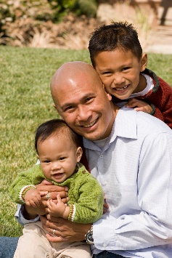
Connecting Fathers Workgroup
January 7th, 10am-11am
724 Quince St SE Olympia Wa AND WebEx - call in information in the appointment and email
Meeting Goals:
- Welcome and Introductions
- Materials Update
- Vroom for Dads
Topic |  | Support Documents
Welcome and Introductions
- Who’s here
- Review Notes for Nov.

Speakers Bureau Power Point  - Feedback?  - Call to Action? | - Need a reference slide with all the literature  - Want to make sure we are dad positive!  - Slide 28 at Six Weeks Old will make sure that we are highlighting that professionals working with families are a majority women and might feel that dad is something “wrong”.  - Slide 34 Gender Identity Nick Will create another slide depending on audience. Focus on fatherhood relationships  - Slide 35 Single Moms: Will remove this slide.  - Slide 36 What about the “deadbeat” Dad: Micah and Tina will rework this into two slides based on DCS information including co-parenting pilots  - Slide 37 Co-parenting Kyle will re work. Want to give our ideal of what we want for children  - Slide 38 Parents making a difference. Nick will re work this slide adding more about capacity. Especially want to make sure the last sentence is taken out.  - Slide 39 Protective Factors. Louis, Nick and Kyle will look at this slide. Will replace Fatherhood with Father child relationship  - Add a slide about direct contacts to fallow up
- Next meetings:
- Tue. Feb.4th , 10-11
- Tue. March 3rd, 10-11
Next Council Meeting: 10:30-12 Feb. 14th and Part 2 Telling your story with a Purpose 12-2

