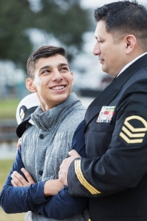
Connecting Fathers Workgroup Notes
May 5th, 10am-11am

Meeting Goals:
- Welcome and Introductions
- Federal Grant Opportunities
- Vroom Grant
Attendees: Louis Mendoza, Tina Burnquist, Ellen Nolan, Anne Stone, Nelson Rascon, Nicholas Kosovac, Micha Jackson, Kyle Paskewitz, Dante Pollard, John Cottrell, Jeremiah Donier Guest: Greg Marris

Topic | Notes
Welcome and Introductions  - Who’s here  - Review Notes for March | - We are excited to have so many join us virtually today  - Greg Marris joins us from the Colville tribes. Does home visiting with mothers and wants to get more connected to Fatherhood programs.
Federal Grant Opportunity  - Charting a Course for Economic Mobility and Responsible Parenting Potential Grant Partners  - Fathering in 15(TM) Overview video  - Fatherhood Family-focused, Interconnected, Resilient, and Essential Grants (Fatherhood FIRE) | - Looking at partnering with Washington Communities for Children.  - The National Fatherhood Initiative put out Fathering in 15 a flexible selection of online modules.  - Exploring how to connect with high school GRADS programs  - Louis suggested the need for a clear mission statement to help evaluate if grants are working towards a common goal.  - We want to think about a way for organizations to continue their learning and education  - John is watching for FIRE closely. It will work with Fathers 18 years or older and with children under the age of 25
Vroom Grant  - How are we moving forward at this time? | - John is using the app around his home and finding lots of good suggestions that are applicable to older children.
Adjourn
- Next meetings:
- Tue. June 2nd, 10-11
- Tue. July 7th, 10-11
- Tue. Aug. 4th, 10-11
- Fatherhood Council Meetings May 8th 10:30-12:00

